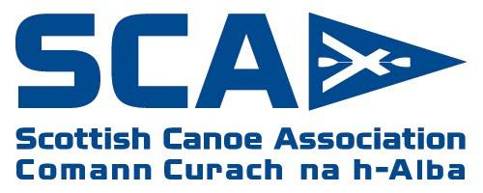
SCA report to SAPOE
Report for meeting – March 2019

- Both the NEW Paddlesport Instructor and Personal Performance Awards are now officially launched with programmes up and running throughout Scotland. In Scotland we have a network of 43 tutors licenced to deliver Paddlesport Instructor qualification.
- Certification for the Paddle Start (FREE) and Paddle Discover (£6) are now through the GO Paddling website providing an efficient and effective way to certificate both awards, with a bulk upload facility to quickly upload a list of names and email addresses - https://gopaddling.info/course-provider-upload-centre/ We are keen for centres to utilise these certification options to give recognition to participants.. Help videos are also available here.
- The new online course authorisation and results module is fully operational along with the online certification of current and historic awards. Coaches can now download a PDF of their certificates.
- The new ‘Provider Finder’ module on SCA website provides a listing of course providers who have opted to be listed.
- The new course and events map now lists lots of opportunities around the country. canoescotland.org/finder
- On the British Canoeing website, ‘My Pathway’ has received a facelift and new content added to incorporate the NEW Paddlesport Instructor and Personal Performance Awards: www.britishcanoeing.org.uk/coaching-leadership/my- pathway
- Whilst we have received excellent feedback on the new awards (Paddlesport Instructor, Paddlesport Leader, Coach Award and Personal Performance Awards), we are also mindful of the need to reassure coaches with existing qualifications that they remain valid and there is no obligation to progress. There are many options for CPD and qualification progression. The British Canoeing Environmental Definitions & Deployment Guidance for Instructors, Coaches & Leaders lists the recommended remits of all qualifications in simple clear language irrespective of when the qualification was achieved.
- The British Canoeing Coaching Philosophy is at the heart of decisions; putting the paddler at the forefront.
- By demand, the Coach Award options will be expanded this summer with the introduction of Stand Up Paddleboard Coach Award. We will shortly be advertising for tutors. Pathways include: Sheltered Water SUP, Open Water SUP, White Water SUP and Race SUP Coach Award
- Introduction to Paddleability – The Foundation Module has undergone a review. The new format and content will be made available in Easter 2019 for existing Tutors to start delivery. The NEW workshop will be made available to anyone, opening up access and developing a better understanding of people with a disability. We are keen for more tutors for this course and for centres interested in hosting a course to get in touch.
- The British Canoeing Awarding Body website (www.britishcanoeingawarding.org.uk) provides full details of all the British Canoeing Awards with the SCA website (canoescotland.org) listing courses, tutor information and more localised info.
- Coaching Matters dates are out and open for bookings for this year. These are one day CPD workshops. We welcome the opportunity to discuss further requests for bespoke CPD to meet the needs of centres
- New partnership in place with Scouts Association to offer dual certification to candidates and the Scout permit scheme has been aligned to www.britishcanoeingawarding.org.uk/scouts/
- Since the launch of the e-learning modules (most of which are free and openly accessible), there have been over 30,000 hits. All are available to access from britishcanoeingawarding.org.uk
- We have established several partnerships with organisations as part of our Partnership Impact Programme including one local Trust. We welcome discussions with further Local Authorities/Trusts to explore paddlesport developments.

Andy Murray
Head of Coaching and Development
andy.murray@canoescotland.org
07900887007

