SAPOE
General Comments
- Appreciate that standards are more succinct – in current climate of reducing bureaucracy this is valuable.
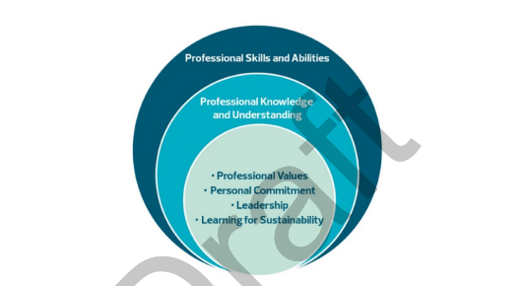
- Why have the ‘Professional Values and Personal Commitment’ been removed from the start of each Standard. Now in a separate document – Introduction to the Professional Standards and the Professional Code. This should remain as the starting point for the standards as the circle diagram shows.
- The statement on LfS has been completely removed from each Standard.
- Through all documents ‘classroom’ is used where, in the majority of places they could use ‘teaching’ ie teaching practice rather than classroom practice.
- Overall general feel is that the progression from provisional to full Standard is mismatched, it doesn’t always ‘flow’.
- Language in general is vague/broad/unambiguous open to individual interpretation ie ‘the holistic development…’
- Lacks aspiration or challenge.
- Feels like a check list of ‘to-dos’

Specifics to each Standard
Provisional and Full Registration
- Removal of professional values and personal commitment
- Removal of Professional commitment
- 2.1.2 – Provisional has “how to develop realistic and coherent interdisciplinary contexts for learning, particularly in relation to sustainability”. Full registration has “ ways in which to work creatively and collaboratively with colleagues to facilitate interdisciplinary learning.”
- 2.1.3 – Provisional has “current educational priorities such as learning for sustainability”. Full has nothing.
- 2.1.3 – Full has only 4 points one of which is – the use of digital technologies when possible… could one be added – application of real world context, or the use of outdoor contexts where appropriate.
- 2.1.4 – Full has “the assessment requirements of the curriculum major awarding and accrediting bodies” – at the exclusion of wider achievement?
- 2.3.1 – Provisional says “the ways in which natural, social, political and economic systems function and how they are interconnected”. Full has nothing.
- 3.1.1 – Full has
- Plan coherent, progressive and stimulating teaching programmes which address the needs of individual learners’, including but not limited to:
• Digital Literacy; • Employability skills; • Equality and diversity. • Global citizenship; • Health and wellbeing; • Learning for Sustainability; • Literacy; • Numeracy
This is very confusing as Global Citizenship is a pillar of Learning for Sustainability so why has it been singled out…. And why hasn’t OL?
- 3.1.3 – Our real carrot – used to say “Employ a range of teaching strategies and resources to meet the needs and abilities of all learners “skilfully deploy a wide variety of innovative resources and teaching approaches, including digital technologies, and where appropriate actively seeking outdoor learning opportunities””.
Now says “create meaningful contexts for learners through a range of different learning environments.”
- 3.2.1 – Used to read 3.2.1 – Create a safe, caring and purposeful learning environment
Student teachers & Registered teachers
“use outdoor learning opportunities, including direct experiences of nature and other learning within and beyond the school boundary.”
This has been left in for provisional but removed for full standard.

Standards for Career Long Professional Learning
- 2.1 removal of Learning for Sustainability
- 3.1 removal of “understand and develop the most appropriate contexts and environments for learning including outdoor learning, and be able to apply appropriate pedagogies for these environments”.
- Complete removal of 3.6 Learning for Sustainability –
  - “understand the environmental, social and economic conditions of learners to inform teaching and learning;
  - have a critical understanding of and engage with the ways in which natural, social, cultural, political and economic systems function and are interconnected;
  - develop the knowledge, skills and practices needed to take decisions which are compatible with a sustainable future in a just and equitable world;
  - connect learners to their dependence on the natural world and develop their sense of belonging to both the local and global community.

Standards for Leadership
- No references to LfS, Outdoor Learning, Nature
- 3.5 – References to resources do not indicate use of greenspace, outdoor space or community spaces. Lost opportunity.

