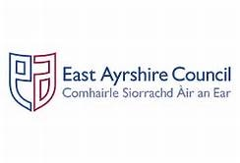
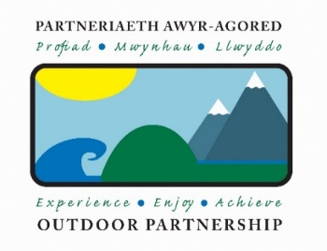

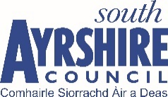

Job title: Ayrshire Outdoor Activity Development Officer
Salary: £28,000 - £30,000 (depending on experience)

This post is being re-advertised

The Outdoor Partnership, established in 2005, is a multi-award-winning charity, inspiring local people to become involved in outdoor activities through participation, education, volunteering, and employment.

The Charity has secured funding from The National Lottery Community Fund to replicate its ethos to other regions in the UK. The ‘Opening Door to the Outdoors’ is a 7-year project and the Charity is seeking to recruit a dynamic, professional and highly skilled Outdoor Activity Development Officer, based in East Ayrshire Council’s Learning Outdoors Support Team in Kilmarnock, with a remit to improve opportunities for more local people to achieve their potential through adventure and outdoor activities across the three Ayrshires. The Post holder will work closely with the Outdoor Partnership (TOP) staff team to implement the Charity’s Strategy as detailed in the duties and responsibilities set out in the Job Description.

For background information on the project, job description and person specification please contact the Programme Manager mark.jones@outdoorpartnership.co.uk at the head office in North Wales and/or visit www.outdoorpartnership.co.uk https://blogs.glowscotland.org.uk/ea/learningoutdoorssupportteam/

To apply please complete and send in the Application Form and letter of application to:

Willie White
Education Officer
Economy and Skills,
Education Service – Learning Outdoors Support Team
St. Joseph’s Campus
Grassyards Road
Kilmarnock
KA37SL
Tel: 01563551457
Willie.White@east-ayrshire.gov.uk

Closing date: Mid-day on the 10th February 2020

Interview date: February the 19th - St. Joseph’s Campus, Kilmarnock

