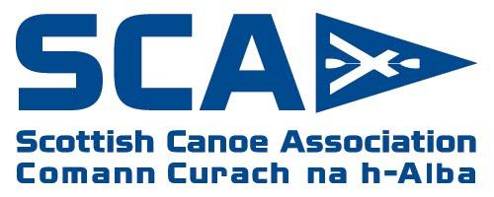
SCA report to SAPOE
Report for meeting – March 2020

- A strong 2019 with completions of coaching, safety and leadership awards.
- New Personal Performance Awards are gathering momentum and going strong in some areas. British Canoeing have provided new Guidance Videos, Podcasts
- The new British Canoeing Digital Library, Self Analysis tool and several more free e-learning packages are also now available from www.britishcanoeingawarding.org.uk
- SCA has commenced the development of the next 4 year strategy and will host a series of regional forums in May to engage further with members, non members and others with an interest in paddlesport. Dates will all be on SCA website shortly.
- Coaching Matters dates are out and open for bookings for this year. These are one day CPD workshops. We welcome the opportunity to discuss further requests for bespoke CPD to meet the needs of centres.
- New Performance Coach qualification announced on 2nd January. Tutors/Assessors have now been orientated and qualification will go live on 29th June.

Andy Murray
Head of Coaching and Development
andy.murray@canoescotland.org
07900887007

